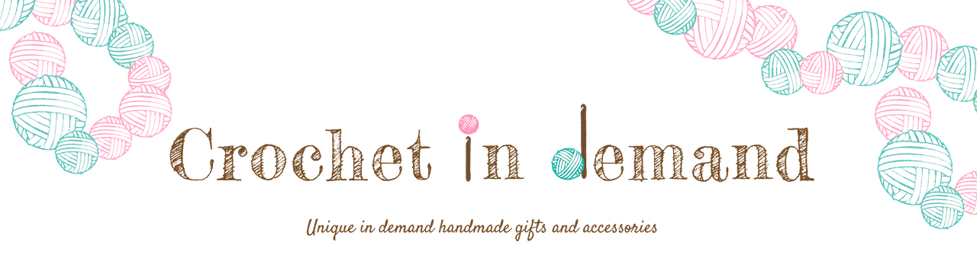
CARE INSTRUCTIONS

I hope you enjoy your Fall Flat Fox plush from Crochet In Demand!
This item is made from soft acrylic yarn and requires care when cleaning.

You should keep it out of dusty areas. It can be wiped down with a damp cloth.
But should your fox have any dirty misadventures; tough stains
can be spot cleaned with a mild detergent and toothbrush and allowed to air dry.

Please note: Although the Fall Flat Fox has safety eyes; they can still pose a choking hazard.
Remove promptly if they should fall off.

I hope you’ll leave a review on your Etsy order and share
any play/collection pictures!
Go to: www.CrochetInDemand.com/Reviews

To purchase items or request a custom item go to:
www.CrochetInDemand.Etsy.com
Use coupon code: THANKYOU for 10% off when you spend $20
Share with your friends!

Any questions or inquiries contact:
crochetindemand@gmail.com or 240-207-1731

Also ‘Follow’ me:
Facebook: CrochetInDemand
Instagram: @Chelle_Creates
Pinterest: CrochetInDemand

I hope to craft your next
IN Demand
crochet gift!

